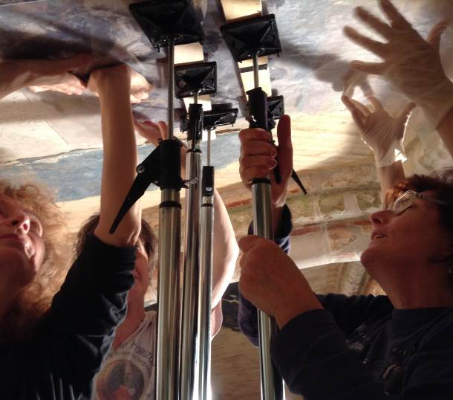

"HAND-MADE SOLUTIONS OF MAN-MADE DISASTERS"
II. International Meeting
ICOMOS International Scientific Committee of MURAL PAINTING
Esztergom (Hungary), 19th - 21th June 2014
Objective of the meeting:
The objective of the meeting is to share with mural painting’s conservators, technical, esthetical and deontological solutions, when damages on mural paintings have been done by human being fortuitously or thinking doing it well. Therefore, we are not interested in criminalized old interventions in conservation but would like to compare solutions offered and evaluate them in order to protect and valorized the mural painting patrimony. In parallel special issue regarding new presentation of mural painting routes and mural painting glossary will be proposed.
Practical Information
Venue and stay:

The symposium will be held in Esztergom (45 km from Budapest) ancient capital of Hungary, in the Auditorium of the main medieval castle, in the Castle Museum of the Hungarian National Museum. Indication will be given to join the Budapest airport to Esztergom, by train or by bus. Economic housing opportunity is proposed. Two hotels are recommended, single and double rooms and mini apartment (4 persons 60 €, 6 persons 80 €). Reservation to be done at http://www.schweidelszallo.hu. , info@ schweidelszallo.hu, http://www.szentadalbert.hu/hotel.php, szallas@szentadalbert.hu
For information: hot meals cost between are in between € 3 and 5€.

Call for papers:

All participants are invited to submit no more than one page abstract (3000 characters maximum) of their contribution before 15th April, 2014, The abstract should contain the Title, Author(s) name and other relevant information (Institution, email address, phone) divided in three paragraphs (introduction with justification of the subject, main central text presenting the problem and different solutions with strong and weak points expressed, and conclusion. The presentation has to be participant’s own creation and previously not presented to any other meeting or submitted for publication. The abstract should be submitted icomos.muralpainting.org@gmail.com
Only accepted abstracts by ISC board the 1st May, 2014 will be scheduled for presentation.

Registration fee: 60 €,
free for MP ISC board’s members (but not including the welcome-dinner) Participants are recommended to be a future member of ICOMOS ISC working group.
Working language:
The working language of the Conference will be English
Programme

Thursday, June 19th, 2014
Arrival of participants
Pre-Conference: VENICE CHARTER 1964-2014.
Possibility for participant to assist the main conference (Optional for ICOMOS ISC working group)

Friday, June 20th, 2014

Morning: Opening of the conference (hall of the castle)
9.00-9.30: Registration of the participants and delivering of the power point presentations of the Session I)
9.30-10.00: Greetings by the Local Authorities
Welcome introductory speech: Zs. Wierdl (President ICOMOS ISC Mural Paintings)
10.00–11.00: First session of presentation of power points by participants on the topic “Hand-made solution to man-made disaster”.
11.00–11.30: coffee break
11.30–13.30: Second session of presentation of power points by participants on the topic “Hand-made solution to man-made disaster”.
(Until 13.30: delivering of the power point presentation of the Session II)
13.30-14h45: Lunch
14.45-16.45: Special visit of the Castle’s Museum’s mural painting worksites (4 different groups with 4 guides which will illustrate the main topic: solutions to detached mural painting, painted stone reconstruction, Botticelli “studiolo” rediscovery, legibility when superposition of painting exist)
16.45-17.15: Coffee break
17.15-18.15: Forth session of presentation of power points by participants on the topic “Hand-made solution to man-made disaster”.
18.15-19.00 Final discussion
20.00 Dinner at “Pince” restaurant (cave of the basilica)

Saturday, June 21th, 2014

9.30-11.30: Fifth session of presentation of power points by participants on the topic “Hand-made solution to man-made disaster”.
11.00–11.30: coffee break
11.30–13.30: Sixth session of presentation of power points by participants on the topic “Hand-made solution to man-made disaster”.
13.30-14h45: Lunch
14.45-16.00: Visit of the Castle’s Museum’s collections and the Christian Art Museum (4 groups)
16.00-16.30: Coffee break
16.30-17.30: What about Past and future routes?
Presentation of new routes
Technical Illustration of optimising 3D routes in Cambodia/Syria
Presentation of models to follow for future routes
17.30–18.30: ICOMOS Mural Painting Glossary (members only)
18.30-19.30 : Board meeting/

Sunday, June 21th, 2014
cultural excursion
(Highland churches of gömör – today slovachia- medieval frescoes)
with prof. Maria Prokopp art historian
Departure

Promoted by:

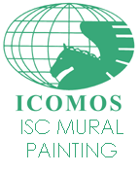 | ICOMOS-International Scientific Committee of Mural Painting
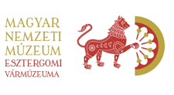 | Castle’s Museum of Esztergom,  Hungarian NationalMuseum, STUDIOLO
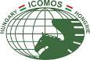 | ICOMOS Hungary

